1. SELECT * FROM fly.flights ORDER BY distance;

SELECT carrier, COUNT(*) FROM fly.flights GROUP BY carrier ORDER BY carrier;

5. SELECT * FROM fly.planes ORDER BY year DESC NULLS FIRST;

6. SELECT model, 2019 - year AS age_in_2019 FROM fly.planes ORDER BY age_in_2019;

SELECT * FROM fly.planes ORDER BY type;

SELECT model, year FROM fly.planes ORDER BY 2019 - year;

SELECT model, type FROM fly.planes ORDER BY type;

7. SELECT arr_time, AVG(arr_delay) AS avg_arr_delay

FROM flights WHERE origin = 'LAX'

GROUP BY arr_time

HAVING avg_arr_delay > 45

LIMIT 1000;

9. Return a few rows from a table to inspect some of the values

Reduce the compute resources used by the SQL engine

Protect against returning an unexpectedly large number of rows

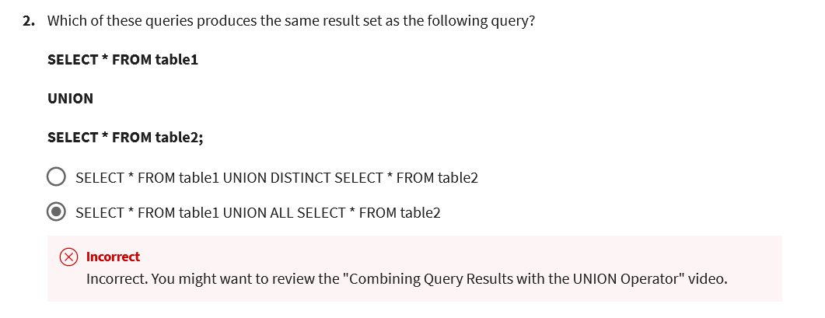

SELECT zip_plus_4 AS zipcode FROM california_emp UNION DISTINCT SELECT CAST(zip AS STRING) AS zipcode FROM california_offices;

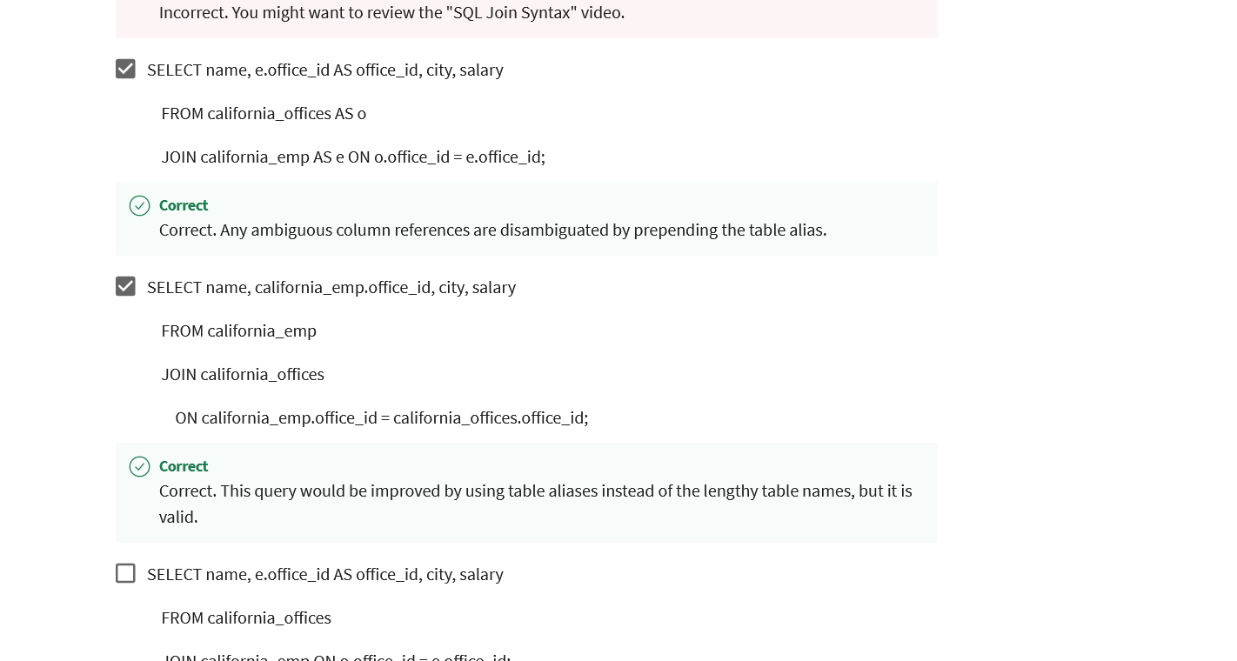

FROM california_emp e LEFT OUTER JOIN california_offices o ON e.office_id=o.office_id

FROM california_emp e RIGHT OUTER JOIN california_offices o ON e.office_id=o.office_id